Customer Partner Access
Partner Registration Guide

You have received an email invitation from the Customer Partner Access (CPA) tool containing your temporary logon ID, temporary password, blank Export Control Status Verification form (C-638), and a link to the registration page.

Prior to accessing the registration page, please complete the C-638 and have your company’s Human Resource or Security Department verify your citizenship and that your company is incorporated in the US. Scan the completed and signed C-638 and have it available to upload when you access the registration website to register.

Northrop Grumman is required to meet strict Personally Identifiable Information (PII) standards dictated by the Federal Government.

CPA can accept and use certain smartcard MLOA hardware certificates for multi-factor authentication; examples include (but not limited to) US government-issued DOD CAC, Exostar, Boeing, Lockheed Martin, or Raytheon certificates. If you do not currently have one of these, an alternative remote access solution will be provided.

Registration Instructions

1. Click on the registration link provided in the email invitation.  Enter the “Registration Username” provided in your invitation email into the User Name field.  Example:  Registration Username: CPA_6000012345  Enter the “Temporary Password” provided in your invitation email into the Password field. Type in the password (copying and pasting the password may add an extra space).  Example:  Temporary Password: 7~C1^RcHjL  Click Login  Notes:  If you have a problem accessing the registration site, ensure that there are no blank characters after the User Name and Password and the values are entered exactly as provided in the email. Tip: Check this by pasting into a document where you can see the User Name and Password.  If problems continue, clear the temporary files in your browser, restart browser, and retry logging in. | 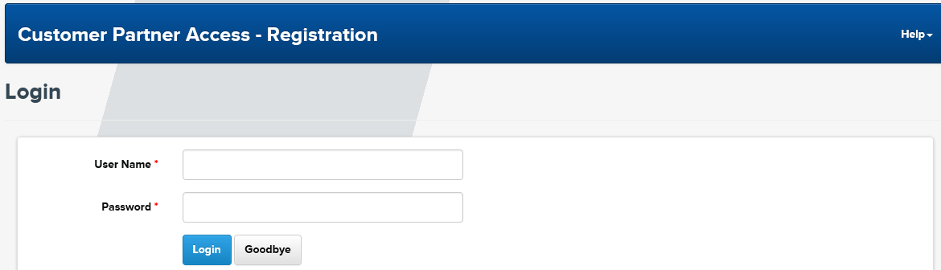
2. The “Password Change” page displays.  The first time you log into registration, you will need to change your registration password. The new password must meet the complexity rules displayed on the screen.  Enter a new password in the New Password and Confirm Password fields.  Remember this password, as it will be entered for subsequent logons to registration, if needed.  Click Continue  Note: To exit registration, click Goodbye. | 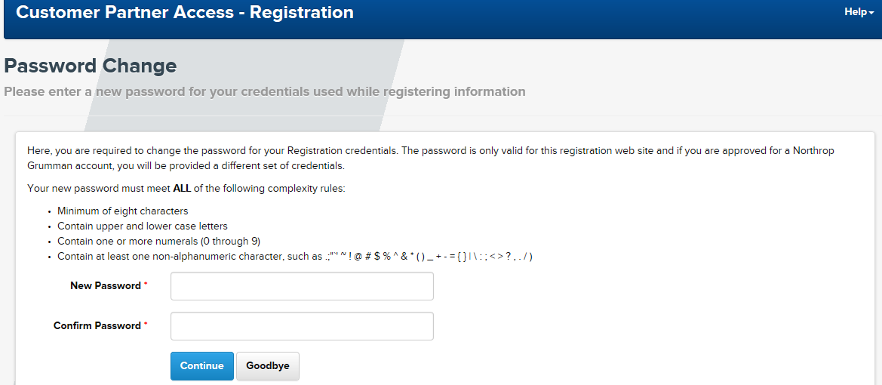
3. The “Invitation to Register” page displays.  Read all of the information.  Click Continue to start registering | 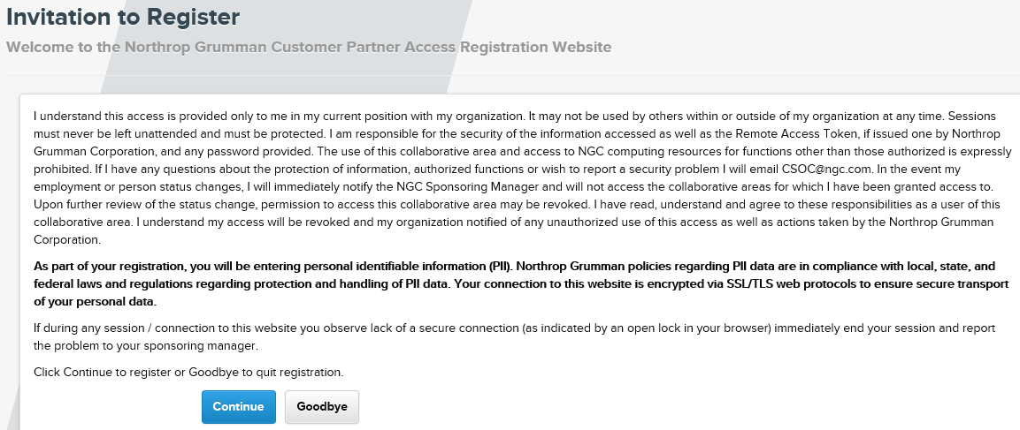
4. The “Personal Information” page displays.  Fields marked with an asterisk (*) are required. Enter your personal information in the fields displayed. This information is required to establish your identity.  Generation field is only used if you have a generation suffix (e.g., Jr., Sr., III)  Select the appropriate country from the Country of Primary Citizenship dropdown.  4.1 US Citizen  Select the Yes radio button for US Citizen  Ensure there is a check in the box next to “I certify that all information I entered on this form is correct and accurate to the best of my knowledge.”  Click Continue  Notes: To return to the previous page, click Back.  If you return to the “Personal Information” page, your personal information will need to be re-entered. | 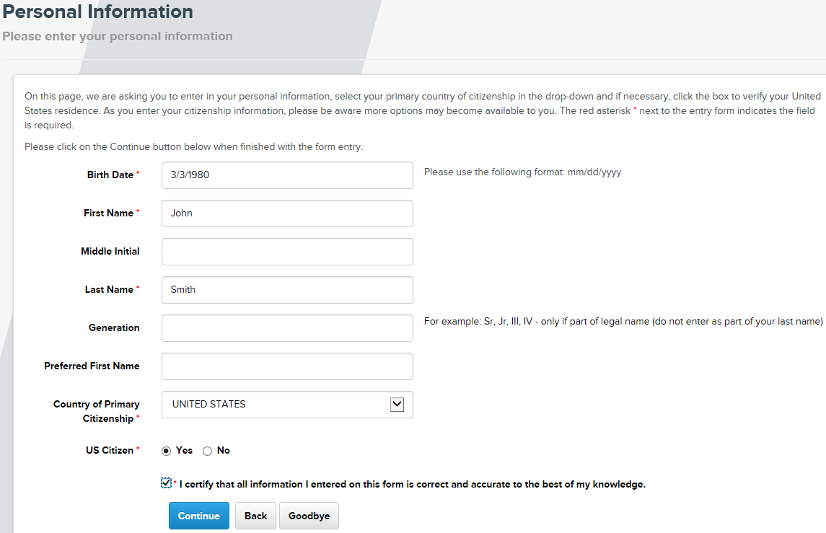
4.2 US Person:  If you are not a US Citizen, but have a green card or SSN, you are a US Person.  You must be a US resident. Check the box next to Verify Residence.  Note: If you are not a US resident, you may not use this registration site to obtain an account. Click Goodbye and contact your primary Northrop Grumman contact or program mailbox, listed at the bottom of your invitation email.  Select the No radio button for US Citizen  Select the Yes radio button for US Person  Enter your number in the Green Card Number field  Ensure there is a check in the box next to “I certify that all information I entered on this form is correct and accurate to the best of my knowledge.”  Click Continue | 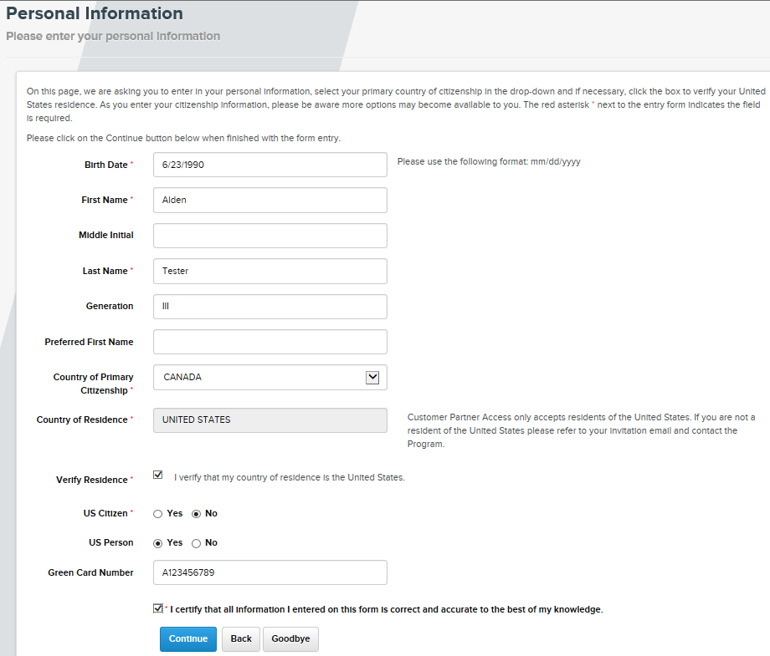
4.3 Non US Person:  If you are not a US Citizen or US Person, you may not use this registration site to obtain an account.  Contact your primary Northrop Grumman contact or program mailbox, listed at the bottom of your invitation email.  Click Goodbye | 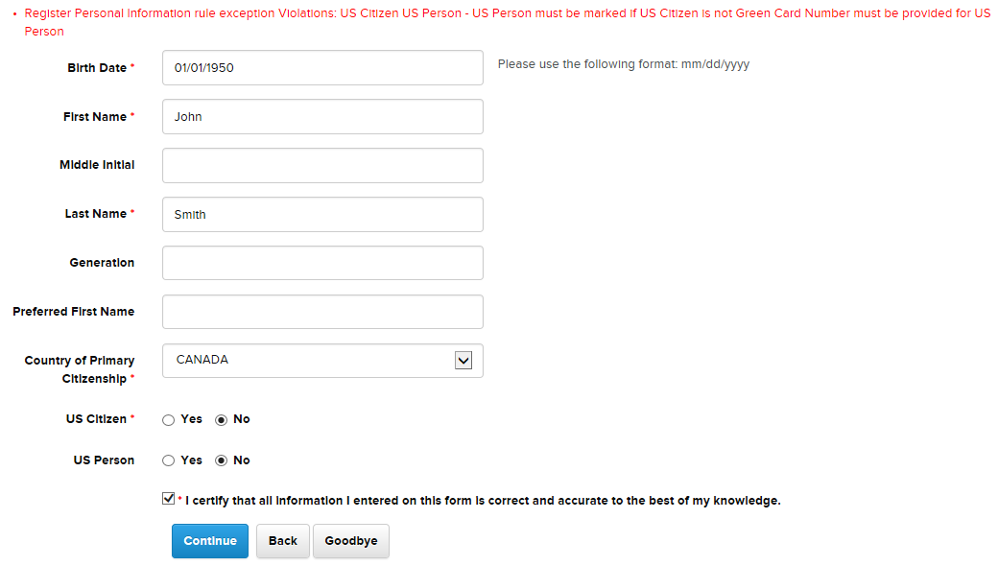

5. The “Company Information” page displays.  Fields marked with an asterisk (*) are required.  Enter the legal name of your company and the corporate address of your company.  Note: If you do not know the corporate address, enter your local business mailing address.  Enter your personal business work information.  Click Continue | 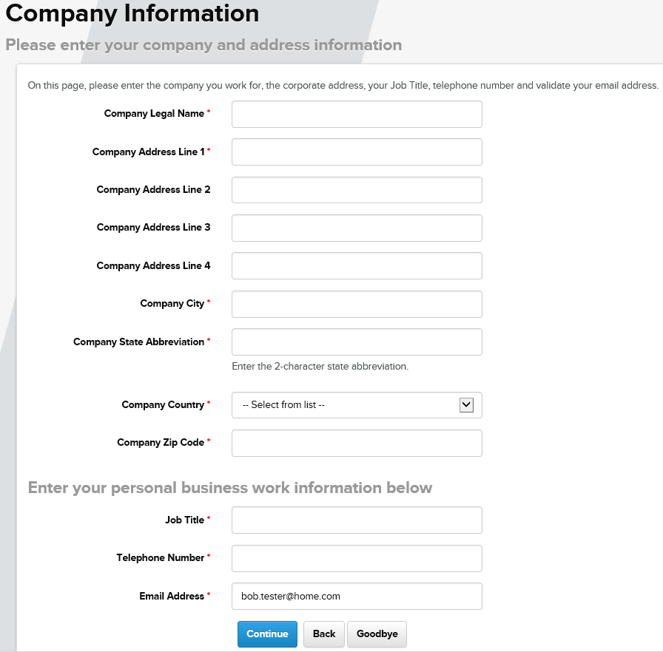
6. The “Business Mailing Address” page displays.  Fields marked with an asterisk (*) are required.  6.1 If your local business mailing address is different than your company’s corporate address, enter your local business mailing address  Note: If you are not using a certificate to authenticate, and you enter a PO box as your business mailing address, you are required to enter a physical address for your shipping address on next screen.  Click Continue | 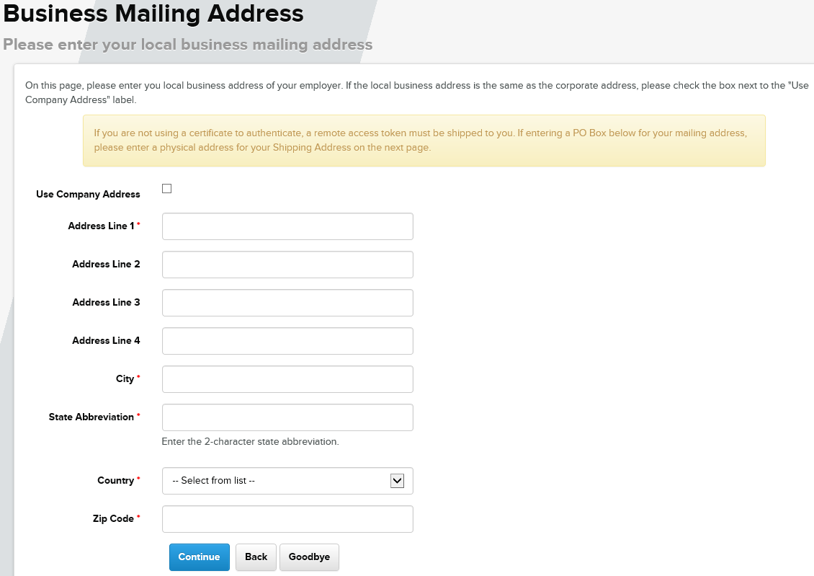
6.2 If your local business mailing address is the same as your company’s corporate address, select the box next to Use Company Address  The fields will “grey out” and you won’t be able to enter information. The address you entered on the Company Information page will be your local business mailing address.  Note: If you are not using a certificate to authenticate, and your company’s mailing address is a PO box, you are required to enter a physical address for your shipping address on next screen.  Click Continue | 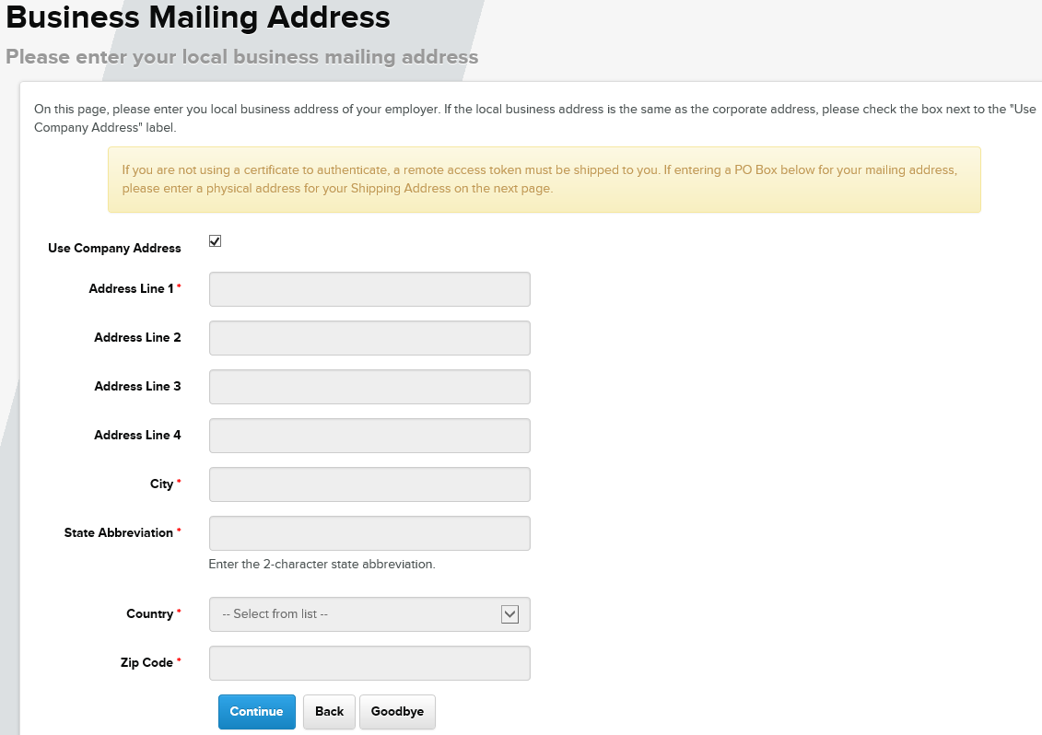

7. The “Shipping Address” page displays.  If you will not be using a certificate to authenticate, your sponsor will request a Northrop Grumman remote access token for you. If you are not able to use a smartphone for the mobile token, a physical token will be shipped to the address you entered for local business mailing address (previous screen) or your company mailing address if they are the same.  Note: Physical tokens cannot be shipped to a PO box  Click Skip if you do not need to enter a shipping address or if you are using a certificate to authenticate.  7.1 If you need a physical token shipped to an address other than your business mailing address, enter the shipping address on this page  Note: You will need to enter a shipping address here if you entered a PO box for your local business mailing address.  Fields marked with an asterisk (*) are required.  Click Continue | 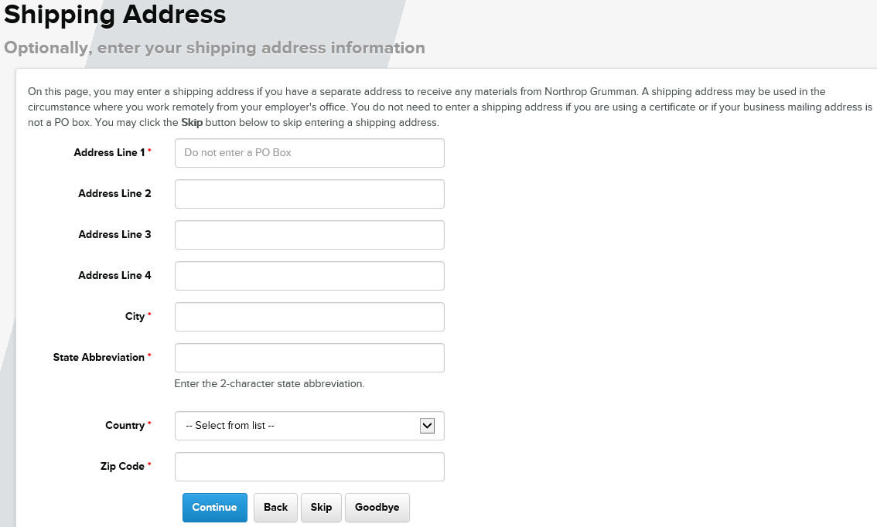

8. The “Identity Authentication” page displays.  Fields marked with an asterisk (*) are required. Enter a response to the security questions. Enter “NA” for ones you do not answer. These are used to authenticate your identity when you contact the Northrop Grumman IT Service Center.  Note: You must answer at least two questions.  Click Continue | 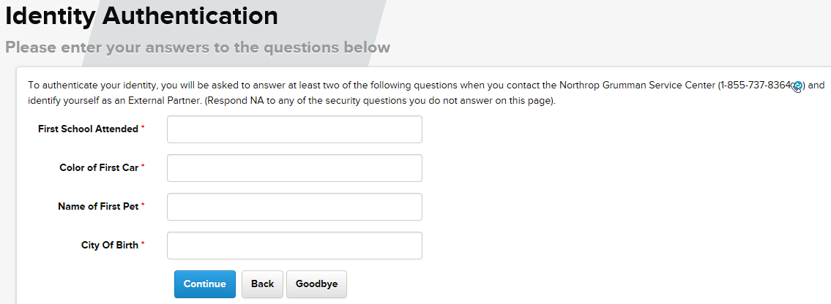
9. The “Documentation” page displays  Have your completed and signed citizenship (C-638) form available to upload. “SECTION 1” and “SECTION 3” must be filled in. The “CERTIFICATION” section must be signed by your HR or Security department.  9.1 Select the Browse button | 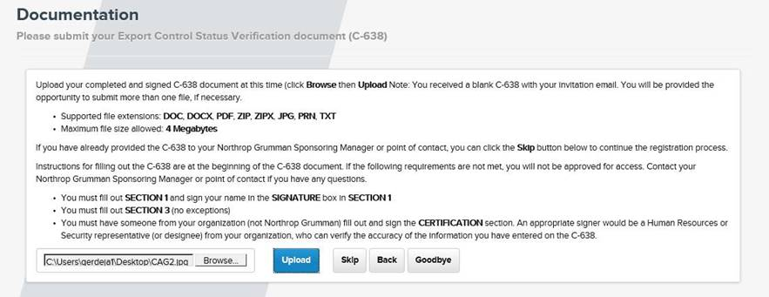
9.2 Select the file and click the Open button
Note: The file cannot be larger than 4 MB and must be one of these file types: DOC, DOCX, PDF, ZIP, ZIPX, JPG, PRN, TXT
9.3 The file that you selected is displayed in the box
Select Upload

9.4 The “Successful upload” message displays  Click More Files and repeat the steps if you have additional files to upload.  Click Continue if there are no other files to upload.  Note: If you have a problem uploading your file, select Skip. You will need to send the file to your sponsor and they can upload it for you during the approval process. They will need the form before they can approve you for an account. | 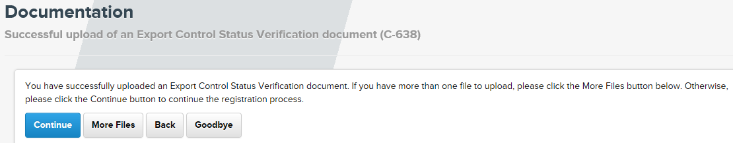
10. The “Authentication Method” page displays.  No certificate:  If you do not have a MLOA (Medium Level of Assurance) hardware certificate that you can use for authentication, click Skip.  Notes: You can check the Northrop Grumman approved list in “Certificate Issuer” dropdown (see next step).  If you do not have an approved certificate to use, your sponsor will request a Northrop Grumman remote access token for authentication for you. | 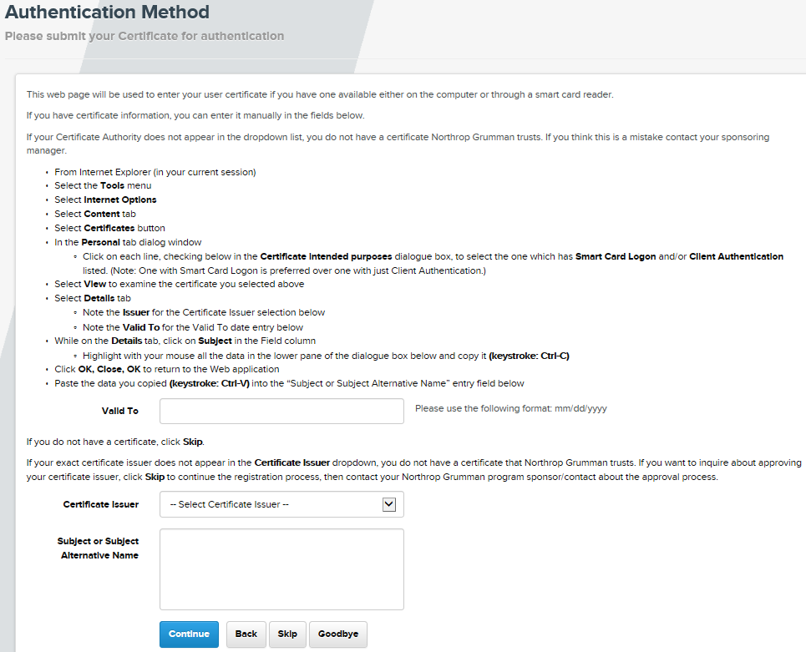
10.1 Certificate:  If you have an MLOA hardware certificate to use for authentication, follow the instructions to view your certificate information.  Select your certificate Issuer from the Certificate Issuer dropdown.  Note: If you do not see your exact Issuer listed in the dropdown, click Skip. Send an email to the program mailbox listed at the bottom of your invitation email and ask that your certificate be approved. Include an exported copy of your certificate (click here for export instructions). | 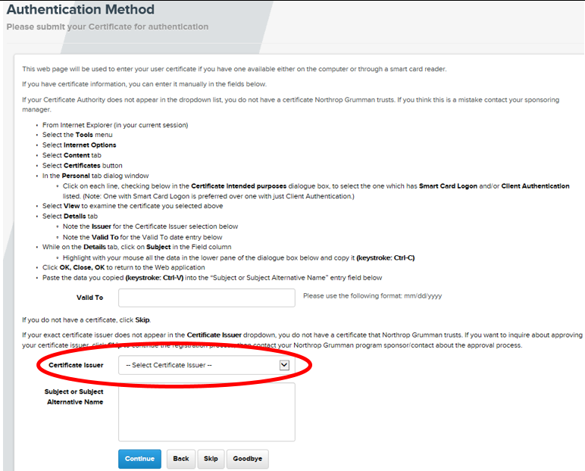
10.2 After you select your Certificate Issuer from the dropdown, the title of the field you need to enter information in will change, depending upon the certificate type  The field title is either Subject or Subject Alternative Name. Take note of this for the next step when you need to copy information from your certificate. | 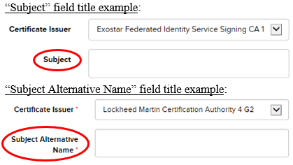

Certificate Examples  An example of what data you should copy out of your certificate will be displayed. The example changes based on which certificate you choose in the Certificate Issuer dropdown. | Example 1  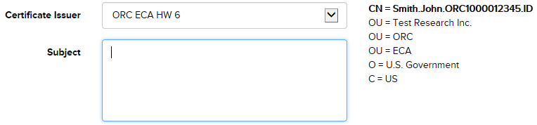  Example 2  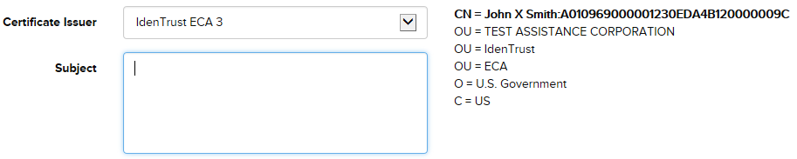
10.3 On the Details tab in your certificate, select the Subject (or Subject Alternative Name) field and copy all of the information in the lower pane of the dialog box  Notes: If you are using an Exostar certificate, the “CN=” value should contain “(Identity)”  Determine whether to copy from the Subject or Subject Alternative Name field from the field title in the previous step. | 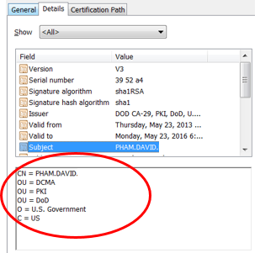
10.4 Paste all of the information into the Subject (or Subject Alternative Name) field in registration  Note: You won’t be able to see everything that you pasted; if you scroll down, you can see everything you pasted.  Add the certificate expiration date in the Valid To field. Ensure that your certificate is not expired; if it is expired, you will not be able to logon.  Click Continue | 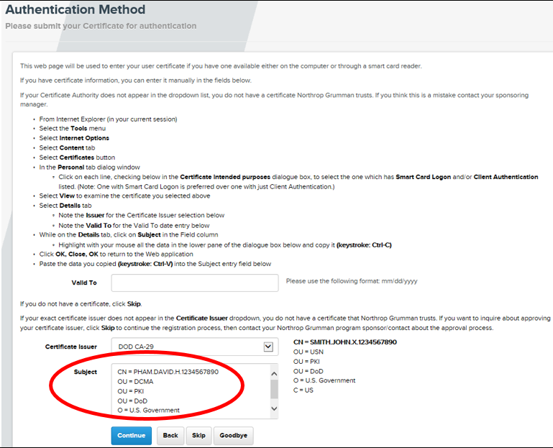
11. The “Terms and Conditions” page displays.  Read the information and select the I Agree radio button.  You may enter a message for the sponsor in the Message for Program Sponsor box.  Click Register  If you do not click “Register”, your registration will not be complete. | 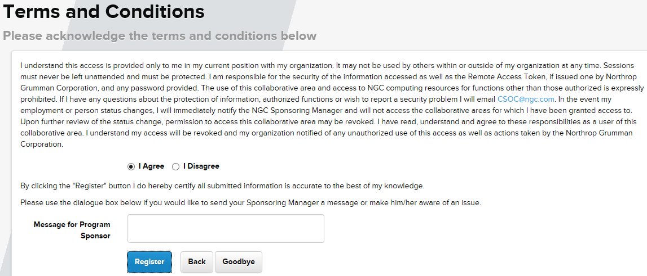

12. The “Registration Complete” page displays.  Close your browser to end the registration session.  CPA will notify the program that you completed registration. The program can now begin the process to on-board your Northrop Grumman account. The program will notify you when ready. | 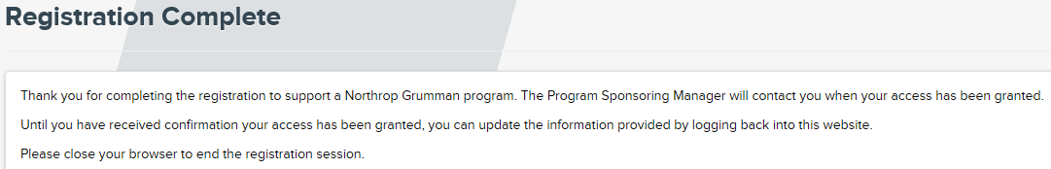

Exporting Certificate

Edge:
- Click …
- Click settings (gear icon)
- In Security heading, click Manage Certificates
- Highlight certificate you want to export, click Export
- Export wizard appears, click Next
- Radio button – No do not export the private key, click Next
- Radio button – DER encoded binary X.509 (.cer), click Next
- Click Browse
- Enter in File Name Lastname.NGCER
- Change Save as type: All files (*.*)
- Note location (folder) of the file being created
- Click Save
- Click Next
- Click Finish
- Click OK
- Click Close for Certificates pane
- Click OK for Internet Options pane

Internet Explorer:
- Select the Tools menu
- Select Internet Options
- Select the Content tab
- Click the Certificates button
- Select the Personal tab
- Highlight the certificate with the intended purposes of “Smart Card Logon” and/or “Client Authentication”
- If more than one certificate is displayed, click each certificate and check below in the “Certificate intended purposes” dialogue. Select the one which has Smart Card Logon and/or Client Authentication listed. The certificate with Smart Card Logon is preferred over one with just Client Authentication.
- Verify that the certificate is not expired
- If Exostar is the Issuer, select the one that contains “Identity”
- Click Export button
- Follow the "wizard" default prompts until you are prompted for the File name
- Click Browse
- Click “Desktop” (or another location that you can find when attaching a file to email)
- Name the file User Last Name Exported Certificate.cer
- Click Save
- Click the remaining default prompts to finish the wizard
- Close all open dialog boxes and exit Internet Explorer
- Attach the exported certificate file just saved on your desktop (or other location) into an e-mail to your sponsoring manager/program mailbox

Certificate Examples

Boeing
CN = John.X.Smith.1234567
OU = certservers
O = Boeing
C = US

Booz Allen Hamilton CA
RFC822 Name=john@simulyze.com

Citibank IdenTrust Certificate Authority
CN = John X Smith:A010969000001230EDA4B120000009C
OU = TEST ASSISTANCE CORPORATION
OU = IdenTrust
OU = ECA
O = U.S. Government
C = US

Class3 (Raytheon)
RFC822 Name=john_x_smith@raytheon.com
Other Name:
Principal Name=ABDC1234@raytheon.com

DHS CA
RFC822 Name=0123456789@dhs.gov
Other Name:
Principal Name=0123456789@HQ.DHS.GOV
Other Name:
2.16.840.1.101.3.6.6=01 19 d7 02 23 d8 21 0c 2c d0 cd 1c e5 45 68 58 21 e3 67 36 f3 30 89 02 10 d7 eb

DOD CA/DOD ID CA/DOD EMAIL CA
CN = SMITH.JOHN.X.1234567890
OU = USN
OU = PKI
OU = DoD
O = U.S. Government
C = US

Entrust Managed Services SSP CA
RFC822 Name=JOHN.SMITH@OPM.GOV

Exostar
CN = John Smith_1234(Identity)
O = Test Systems Corporation North America
DC = fis
DC = evincible
DC = com

HHS
Other Name:
Principal Name=ABC6@cdc.gov
Other Name:
2.16.840.1.101.3.6.6=01 19 d7 2a 10 d8 67 08 6c 44 55 a2 9d a1 45 5a 01 08 48 89 41 b0 23 2a 8c d7 fc

IdenTrust ECA
CN = John X Smith:A010969000001230EDA4B120000009C
OU = TEST ASSISTANCE CORPORATION
OU = IdenTrust
OU = ECA
O = U.S. Government
C = US

Lockheed Martin
Other Name:
Principal Name=e123456@acct03.us.lmco.com

ORC ECA
CN = Smith.John.ORC1000012345.ID
OU = Test Research Inc.
OU = ORC
OU = ECA
O = U.S. Government
C = US

Symantec Client External Certification Authority
RFC822 Name=jsmith@scdit.com
Other Name:
Principal Name=jsmith@scdit.com

VeriSign Client External Certification Authority
RFC822 Name=john@simulyze.com

